**HTML muted Attribute**

Last Updated : 29 Aug, 2024

The **HTML muted Attribute**is used to *specify the audio output of the video is muted*, it is a Boolean attribute.

**Applicable:**

* [<video muted Attribute>](https://www.geeksforgeeks.org/html-video-muted-attribute/?ref=rp)

**Syntax**

<video muted>

**Example:** In this example, we demonstrate the muted attribute in a <video> element, which mutes the audio. It includes two video sources and provides controls for playback.



1

<!DOCTYPE html>

2

<html>

3

​

4

<head>

5

<title>

6

HTML muted Attribute

7

</title>

8

</head>

9

​

10

<body style="text-align: center">

11

​

12

<h1 style="color:green">

13

GeeksforGeeks

14

</h1>

15

<h2 style="font-family:Impact">

16

HTML muted Attribute

17

</h2>

18

<br>

19

​

20

<video id="Test_Video"

21

width="360"

22

height="240"

23

controls muted>

24

​

25

<source src="samplevideo.mp4"

26

type="video/mp4">

27

​

28

<source src="samplevideo.ogg"

29

type="video/ogg">

30

</video>

31

</body>

32

​

33

</html>

**Output:**

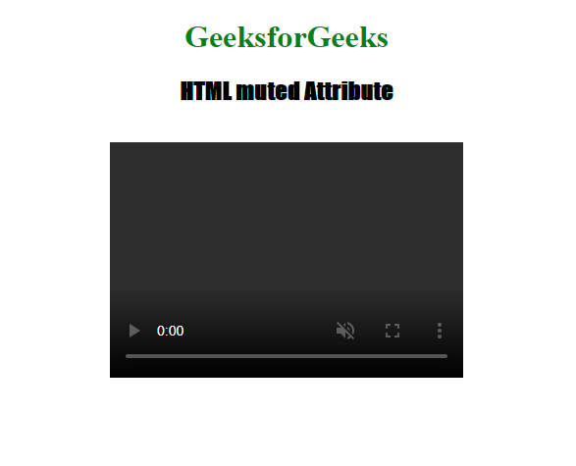

**Supported Browsers:** The browsers supported by **HTML muted Attribute** are listed below:

* Google Chrome 4.0
* Internet Explorer 10.0
* Firefox 11.0
* Apple Safari 7.1
* Opera 10.5